**PDF data extraction using llama-3.3-70b-versatile**

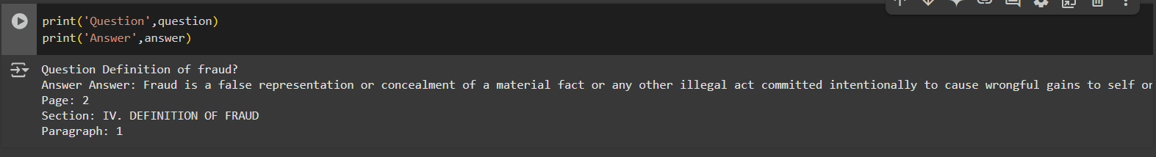

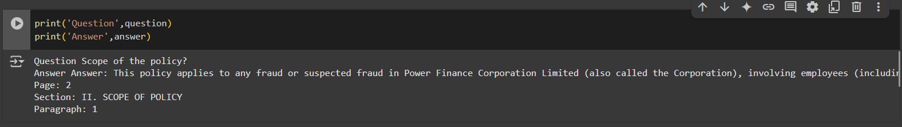

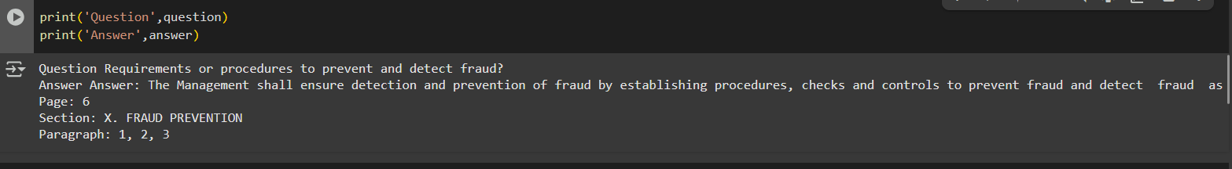

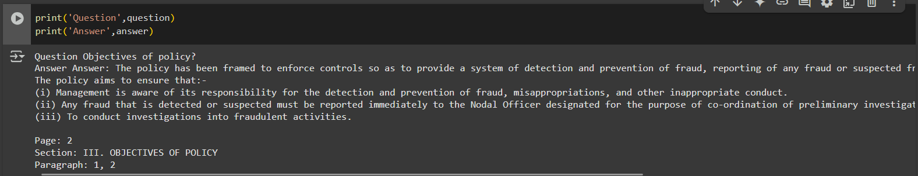

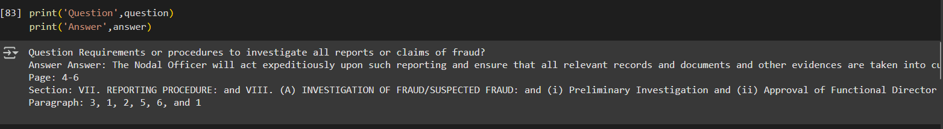

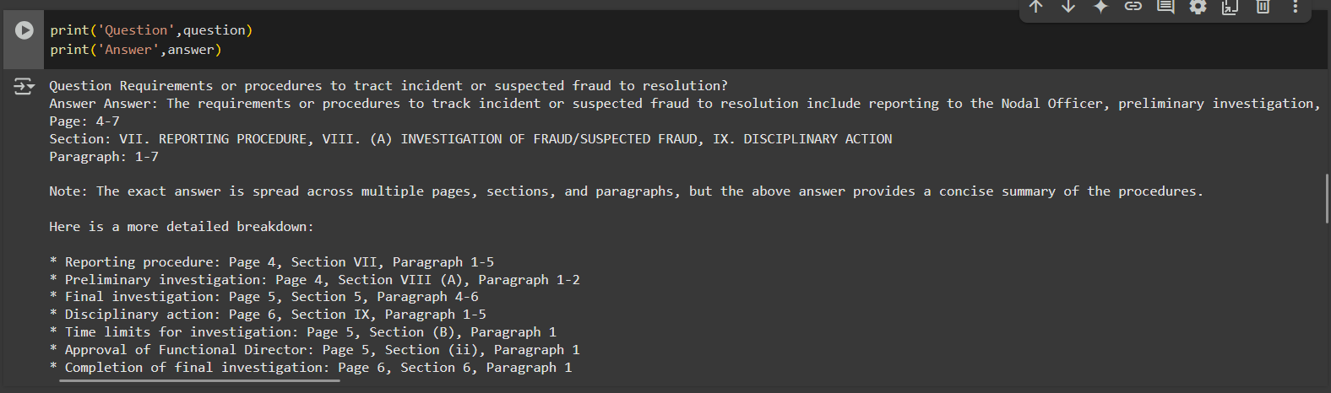

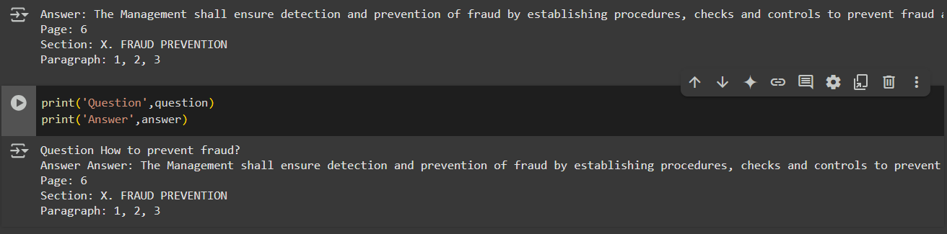

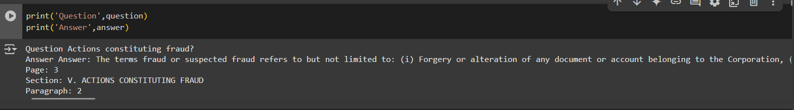

If there is no relevant information:

